**How to perform centralize logging in Micro service Architecture using ELK Stack**

ELK Stack is

* **Elastic Search** - this is NoSQL db to store the logs

- To store data

* **Log stash** - this is log pipeline tool that accepts logs/inputs from various sources

(i.e., log file) and exports that data to various targets (i.e., elastic search)

- To process data

* **Kibana** - This is Visualization UI layer and will help developer to monitor application logs

- To view the data

To perform centralize logging in Micro service Architecture we need to integrate these 3 components

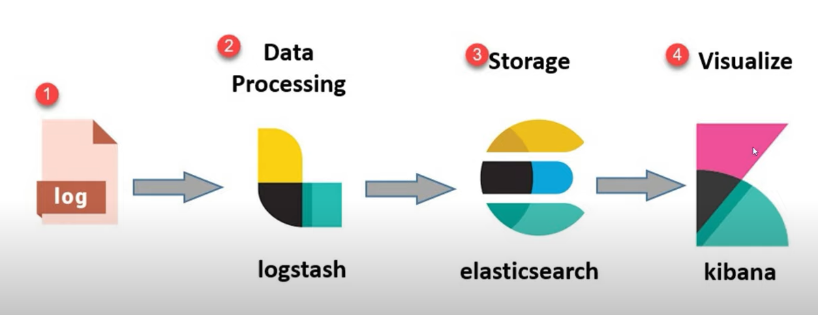

- Once we generate log file of our application we need to give to the **log stash**

**- Log stash** will read this log file and will send to this **Elastic Search**

**- Elastic Search** is NoSQL DB which stores this log data

- **Kibana** will start pulling this log data from Elastic Search to display it in UI

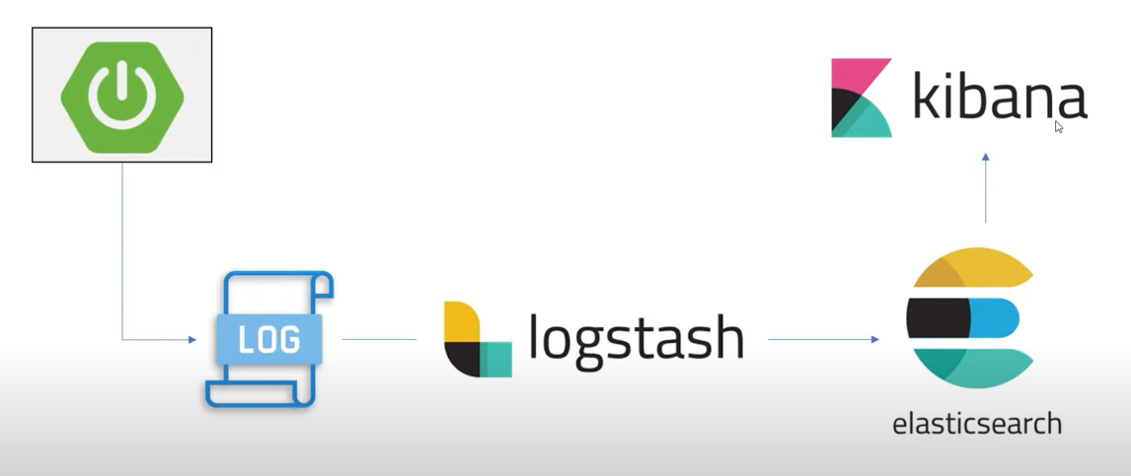

* create one Spring boot project then we **generate the log file of that Spring boot Application**
* Then we will **give this log file to log stash**
* We need to do the configuration that how to **give this log file to log stash**
* Then **log stash will send that data to Elastic Search**
* Explore **how the data is documented in Elastic Search NoSQL DB**
* Then understand how this log data from **Elastic Search** will send to **Kibana**
* This is nothing but how to see the Spring boot logs in Kibana Dashboard

Download all these 3 components and run the batch files and in kibana.yml uncomment the localhost line

elasticsearch.hosts: ["http://localhost:9200"]

if elastic search is started in the console

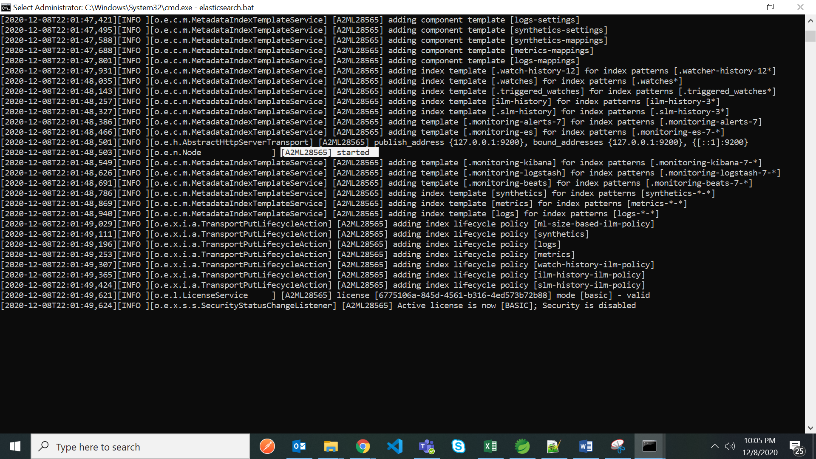

Run this elasticsearch on 9200

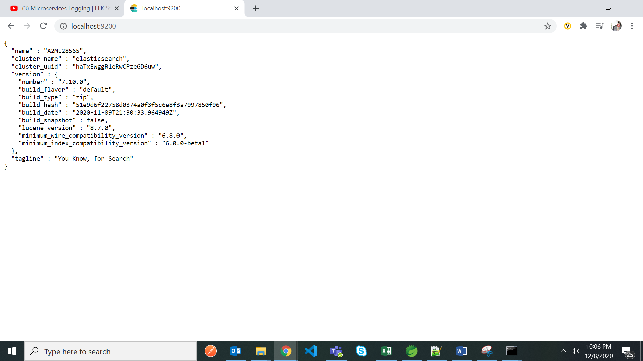

We can see cluster name and few information about elastic search

Kibana console

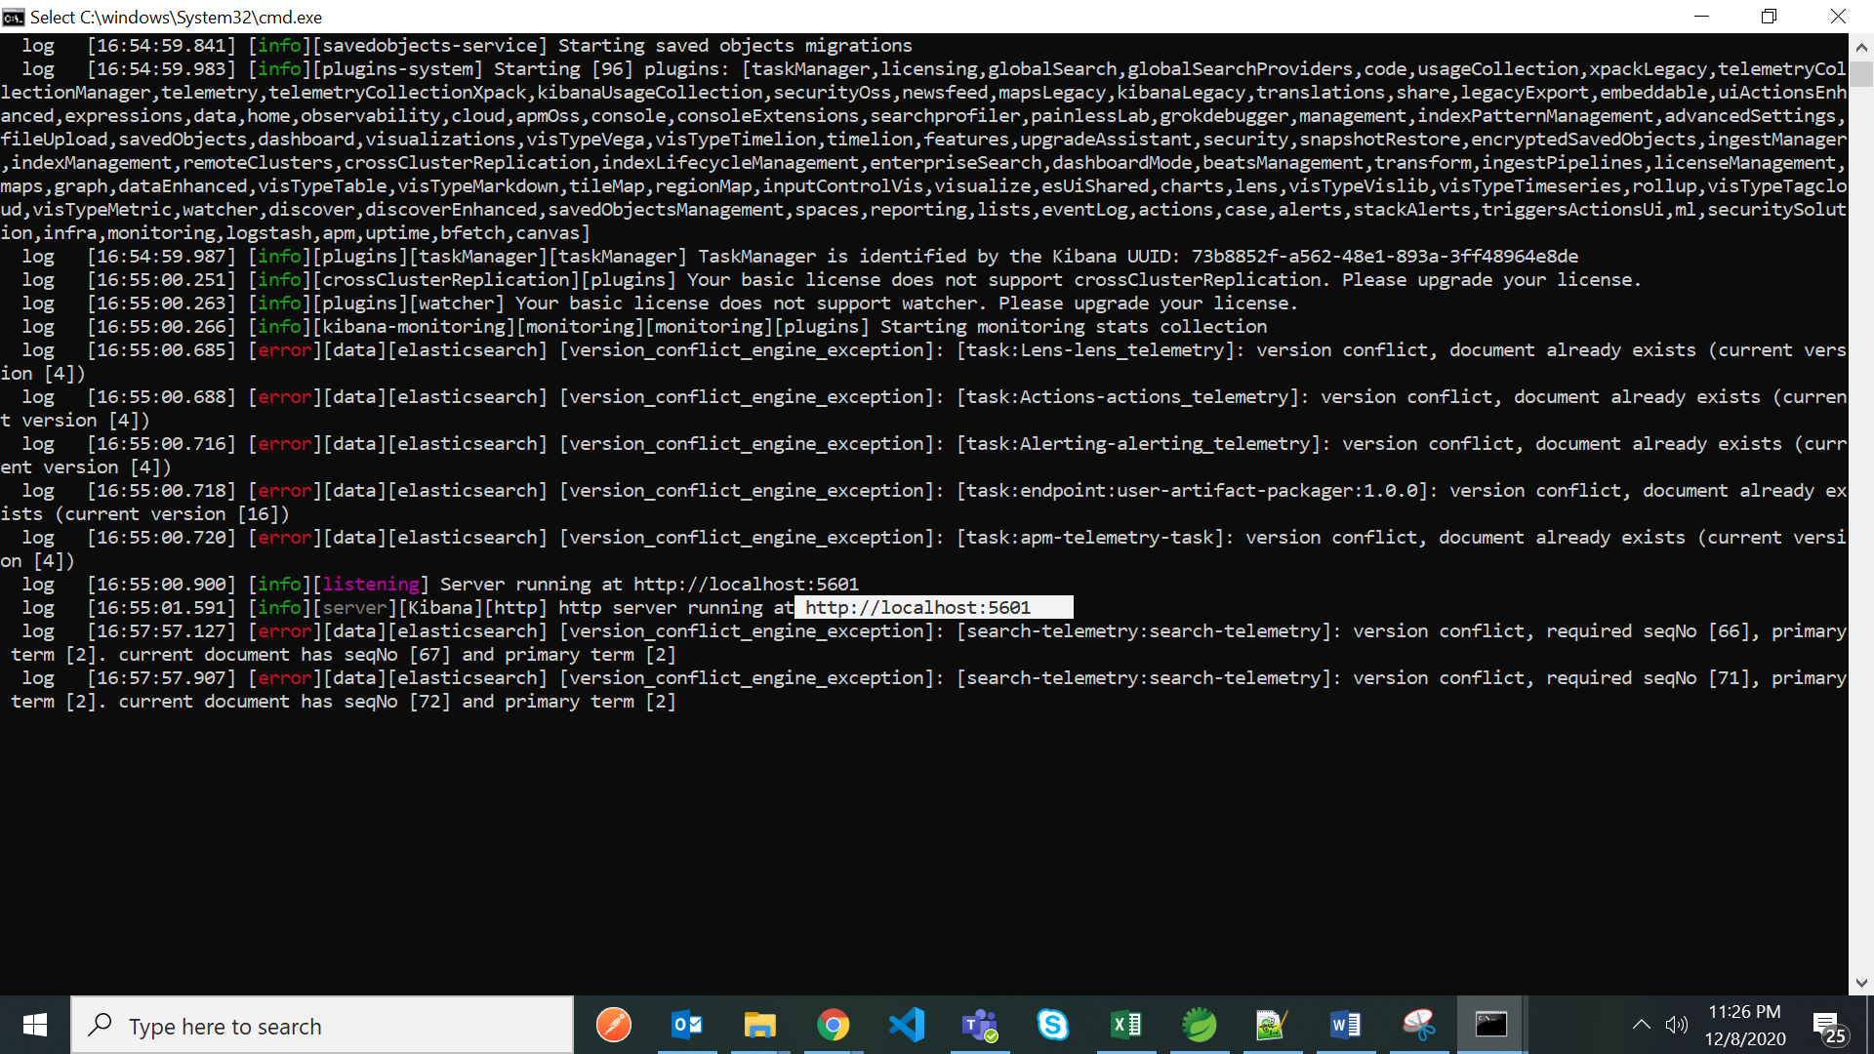

Localhost:5601

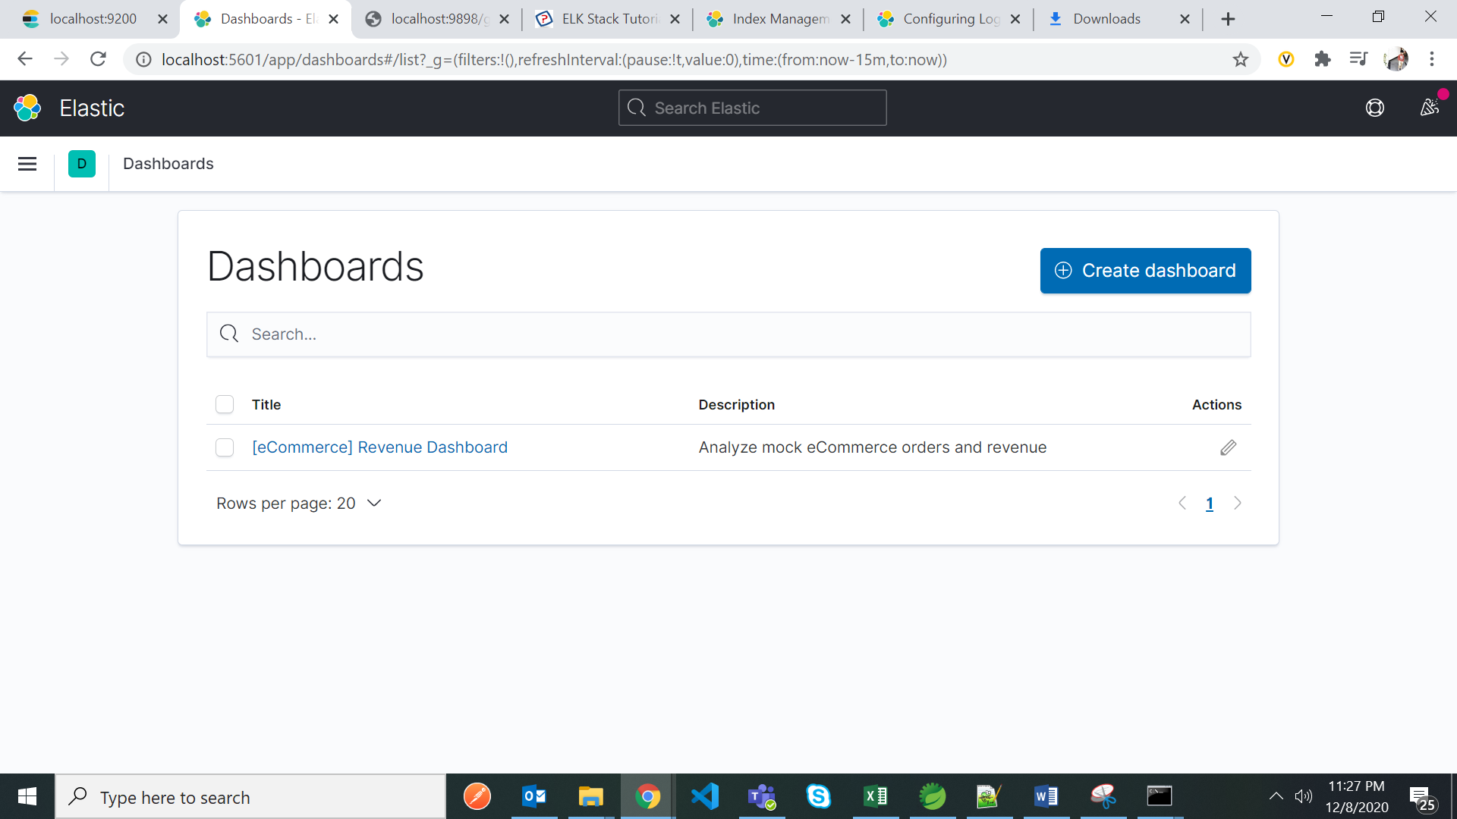

Give the path where log file to be generated like below in application.yml file

spring:

application:

name: ELK-STACK-EXAMPLE

server:

port: 9898

logging:

file: C:\Users\M1058790\Desktop\ELK\logs\elk-springboot-stack.log

Run the springboot application and then log file will be generated in the above location

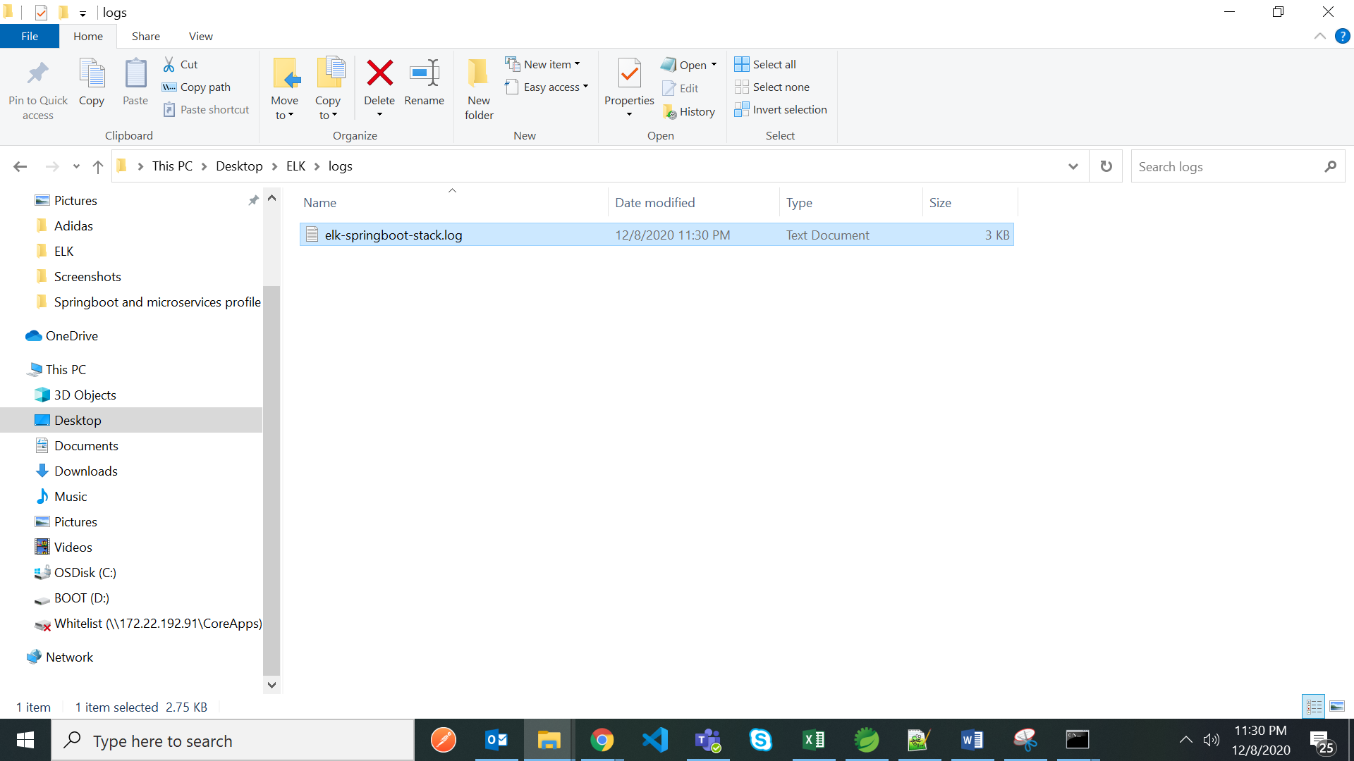

Make a call to rest API

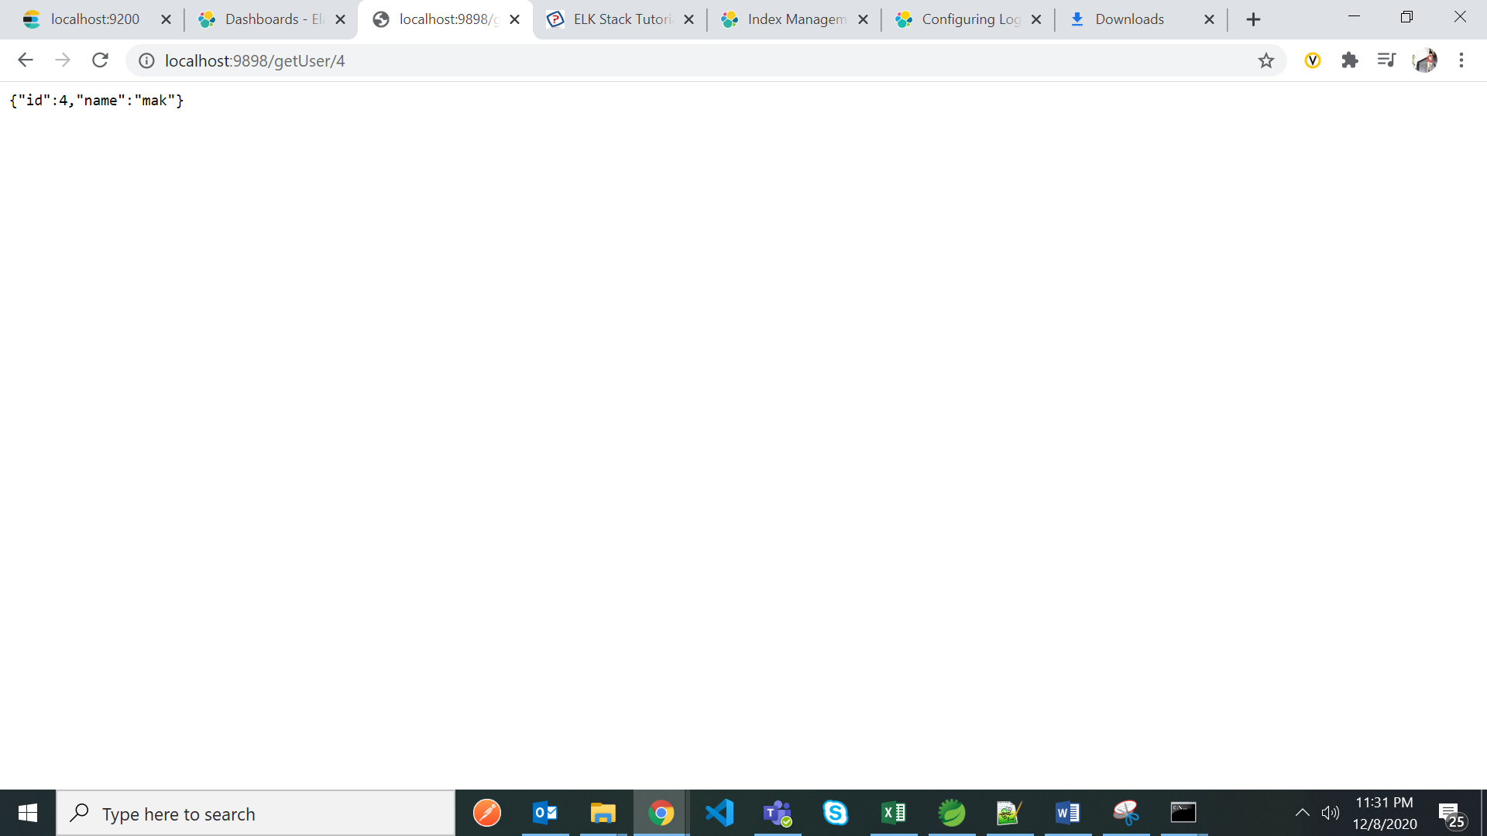

Then in that log file application logs will be available after request is made to rest call

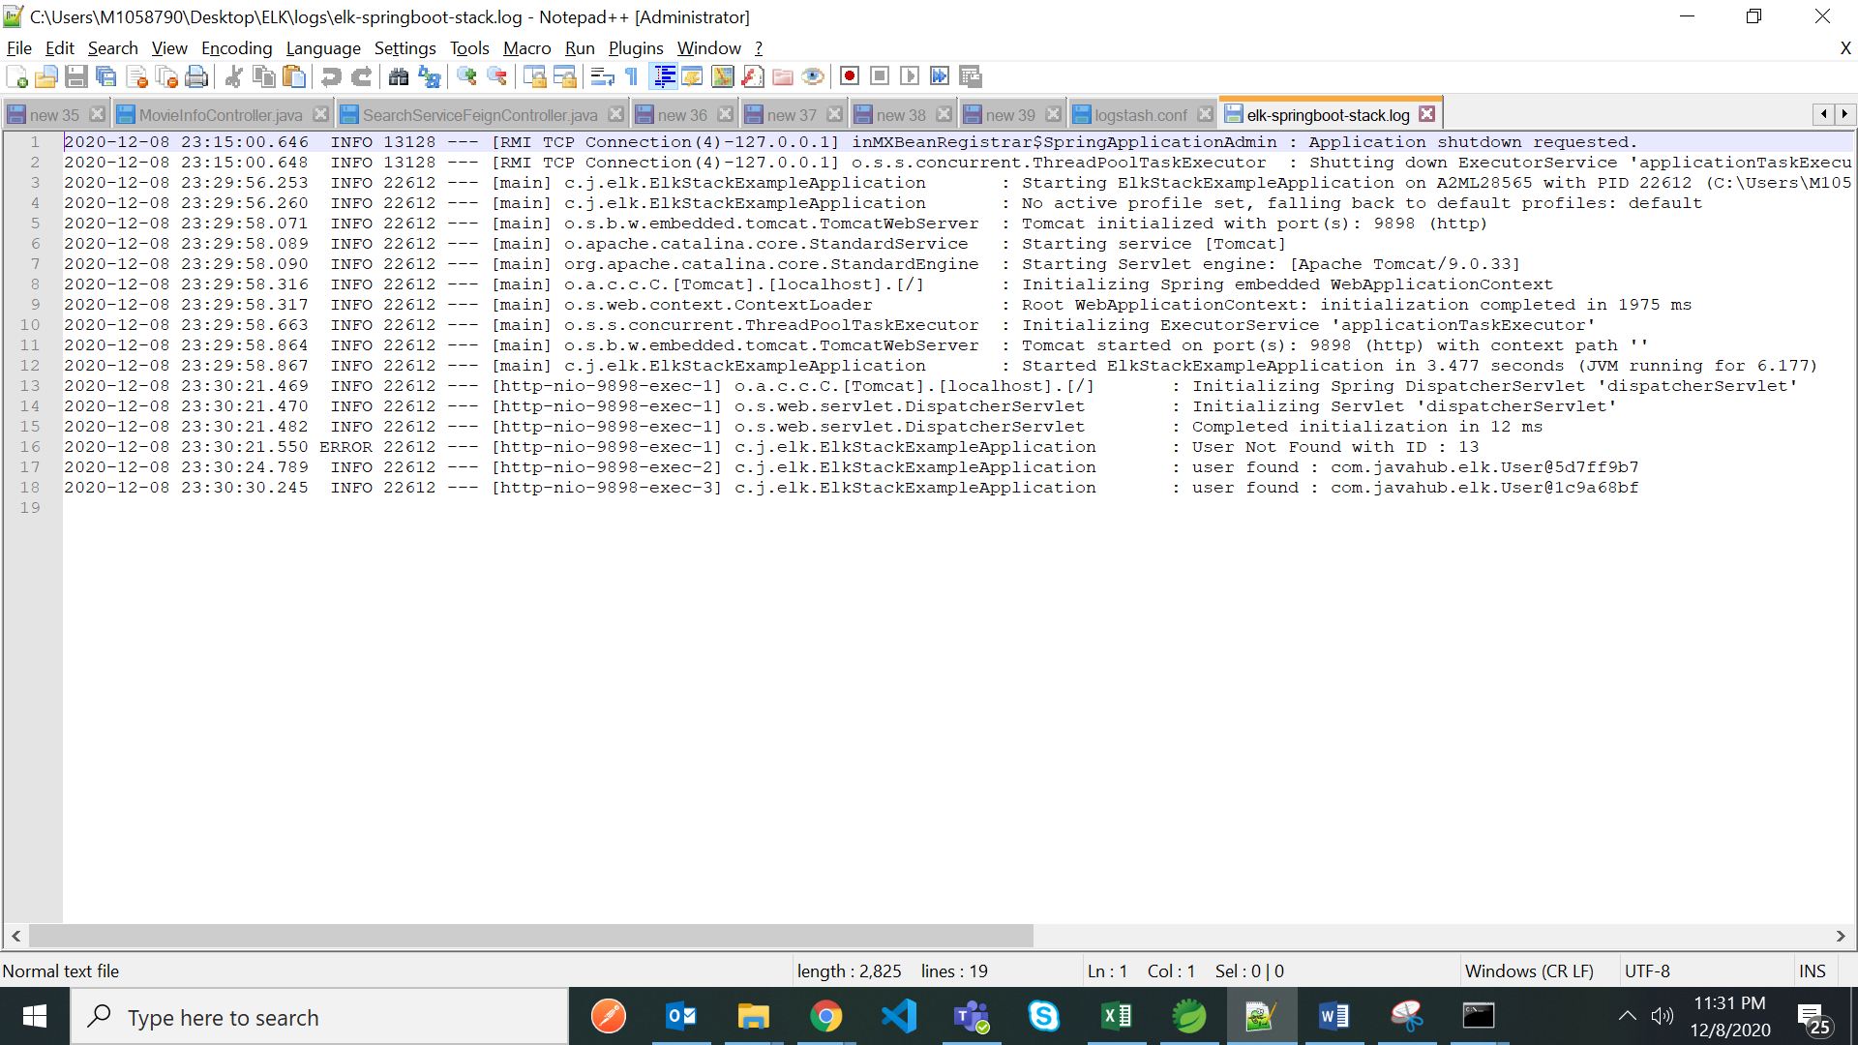

Now clear this log file and save it

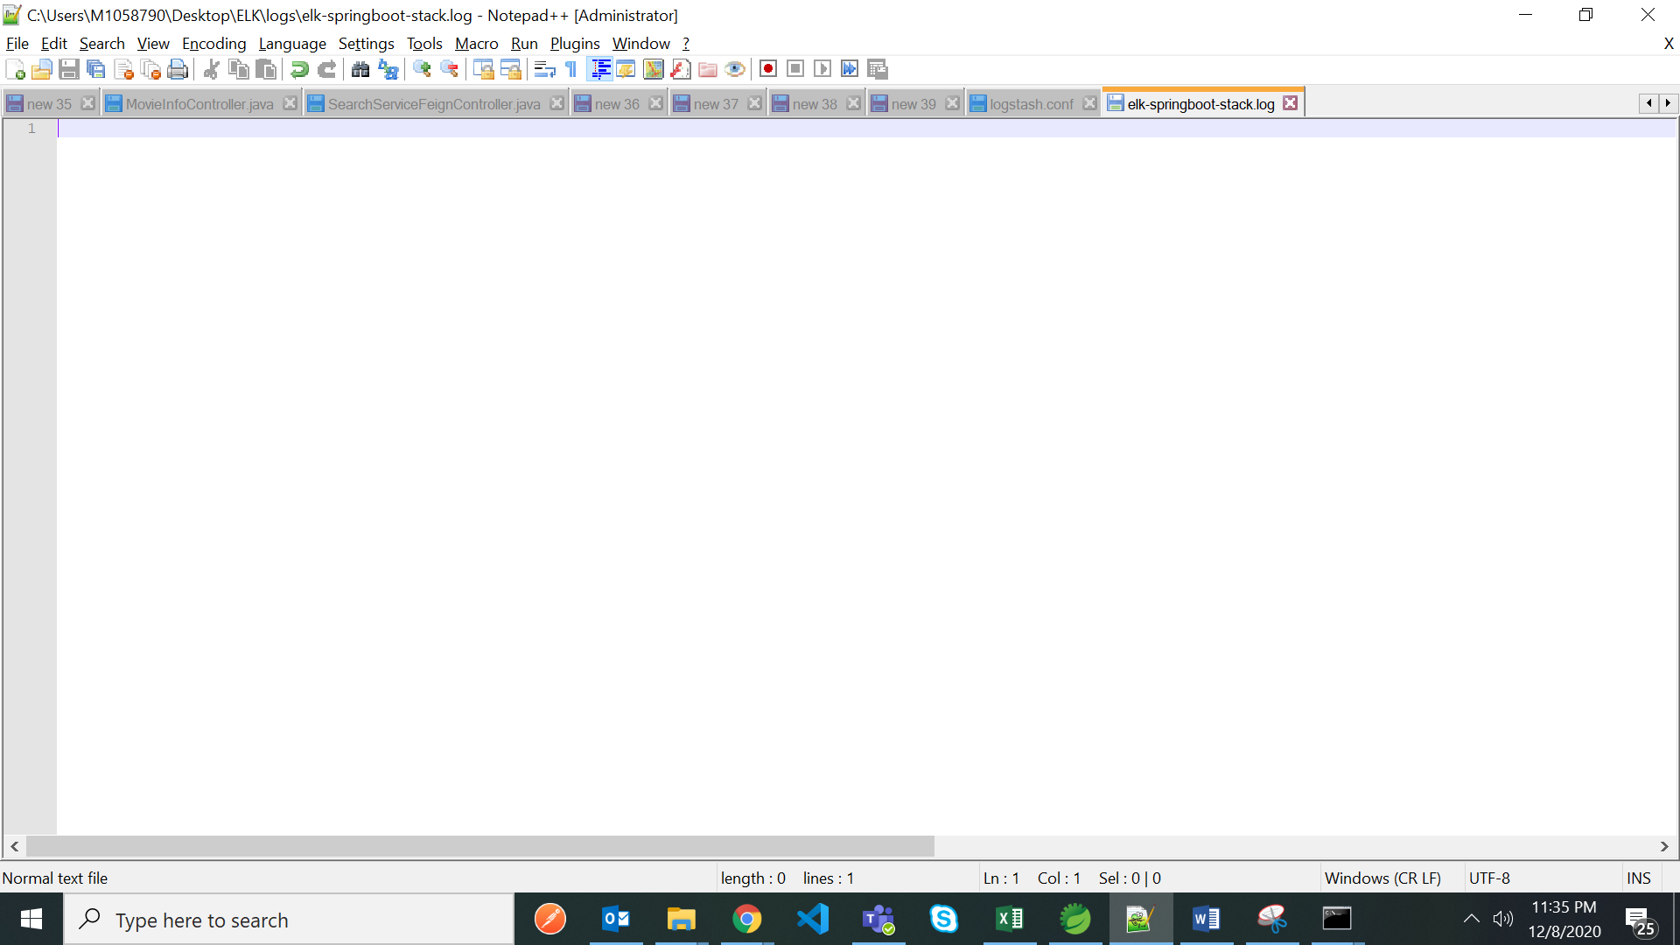

Now configure the logstash then whatever the logs are generated in this log file that full log file will have to push/give to logstash

Stop the application

Now we need to tell the logstash the log file path and read it and process it

For that open logstash documentation for the steps

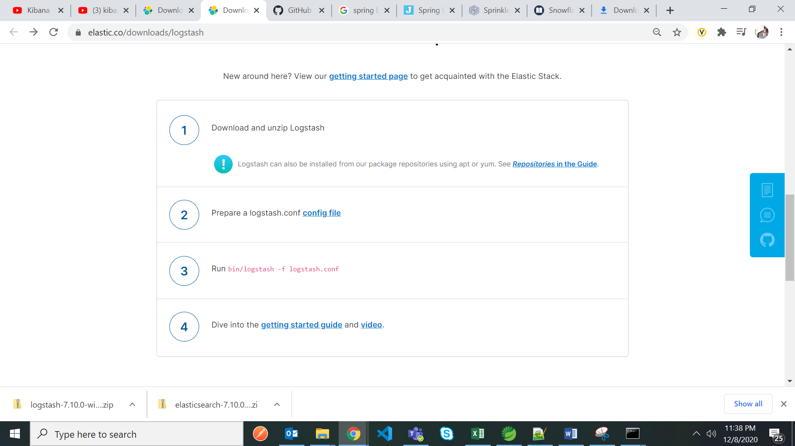

Create logstash file called logstash.conf

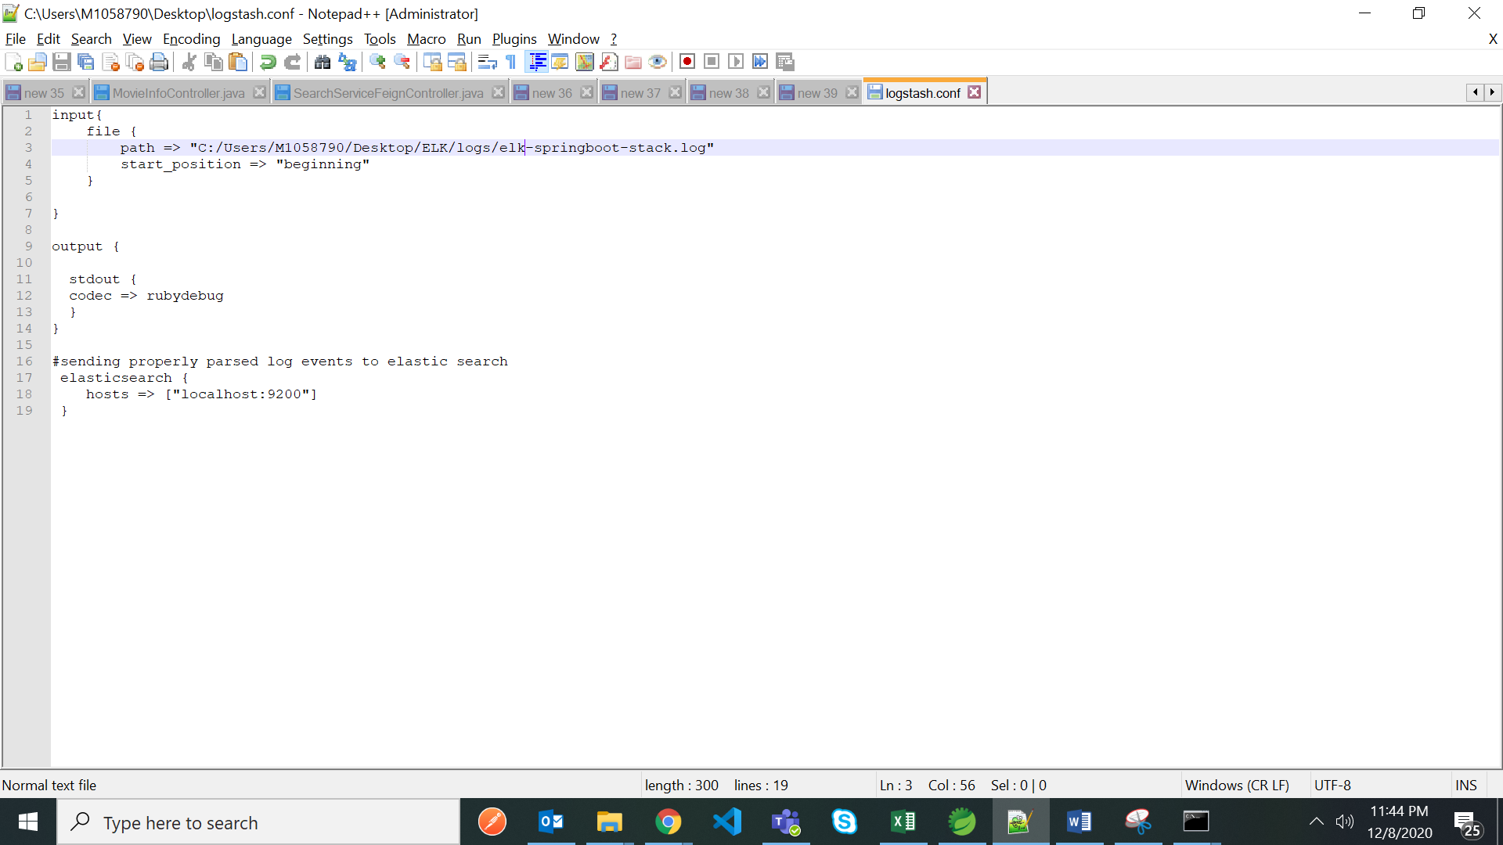

We have to give the log file path(in forward slash ‘/’) to logstash in logstasg.conf file like above

We can check the config file link for reference to prepare the logstash.conf file

copy the log file path or copy it from application.yml file and paste it in logstash.conf file in path property

then logstash will push all log data to elastic search like shown in above logstash.conf file

now copy the logstash.conf in bin folder of logstash

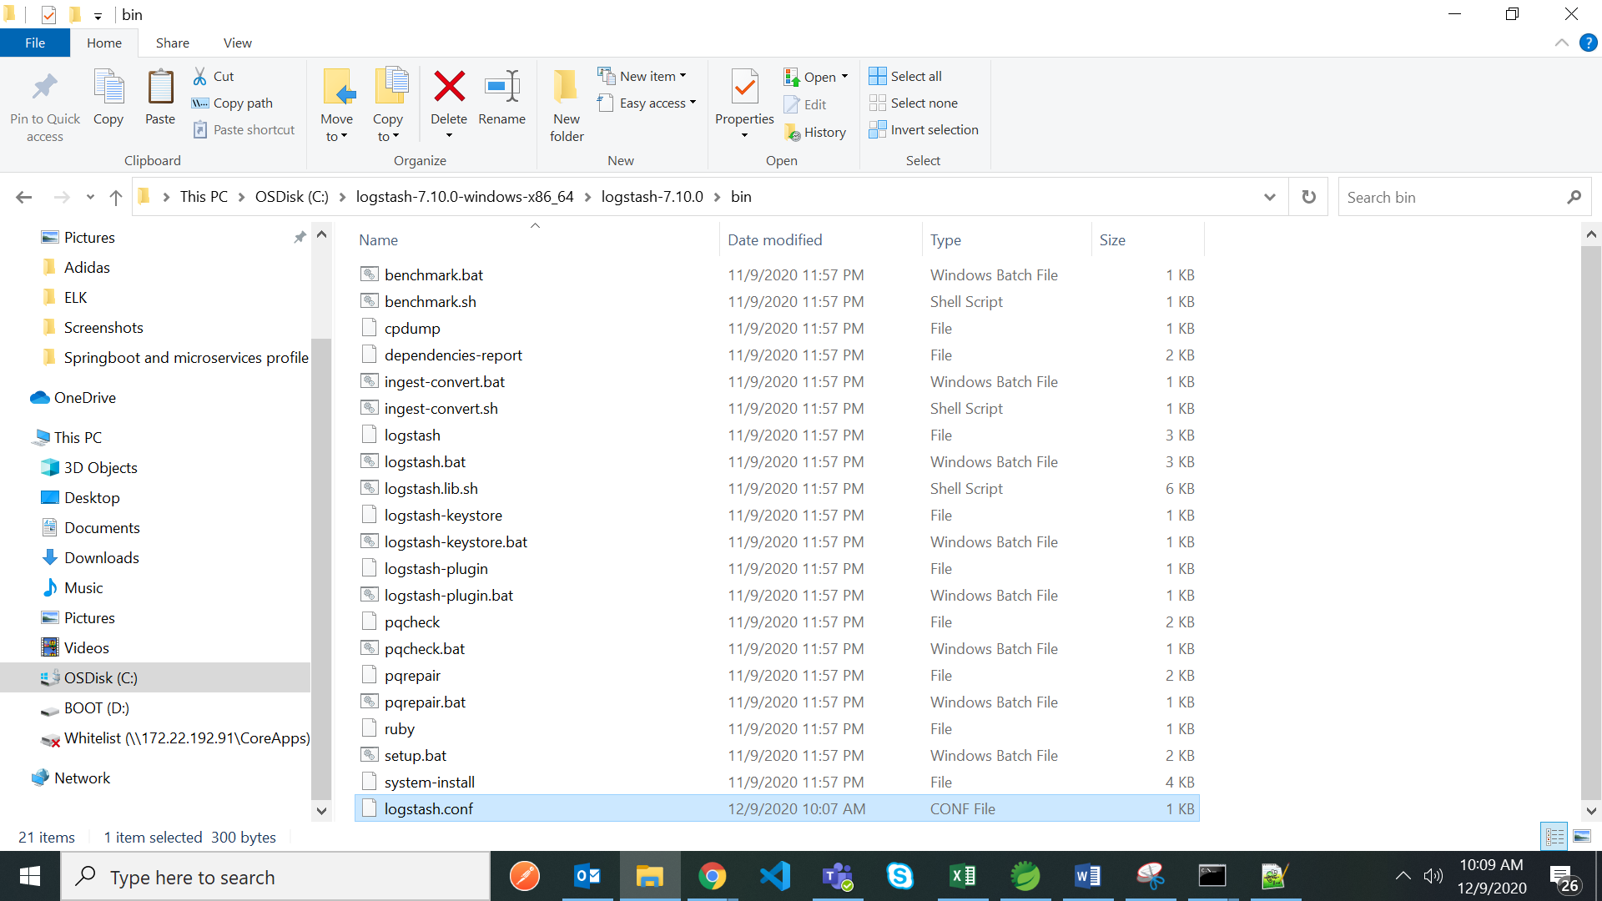

Then open cmd prompt from here and type below command to start the lostash

>logstash -f logstash.conf

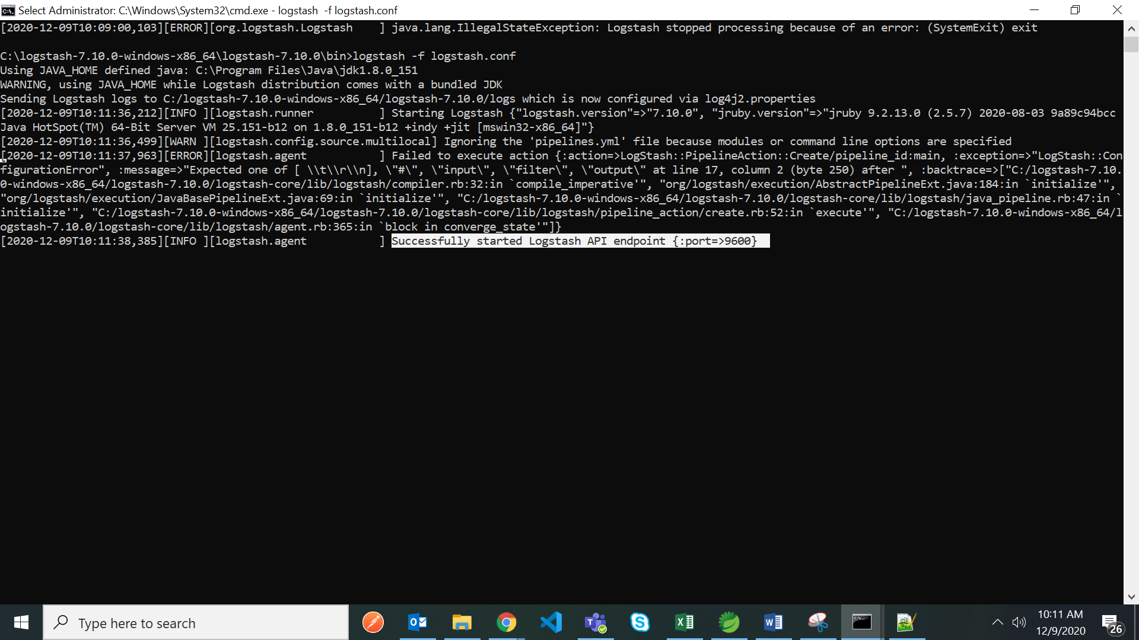

Loagstash started on port 9600

Now start the springboot application

Localhost:9898/getUsers/2

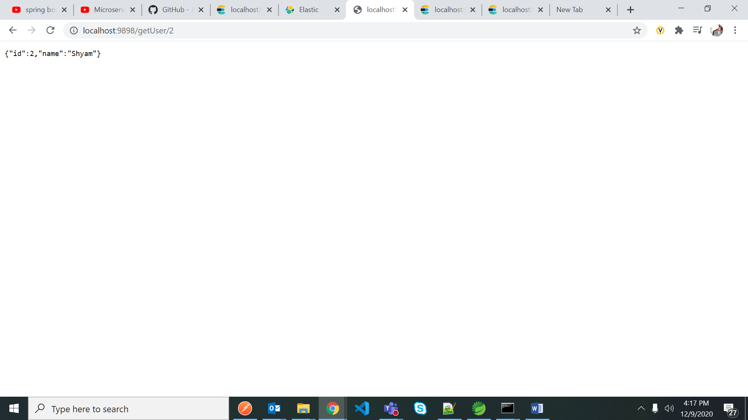

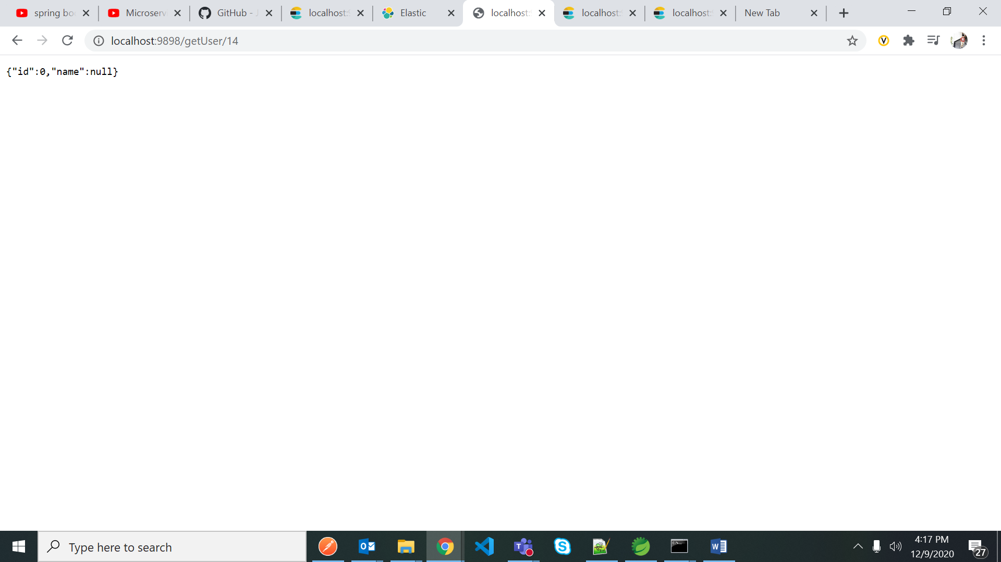

This application logs are in STS console

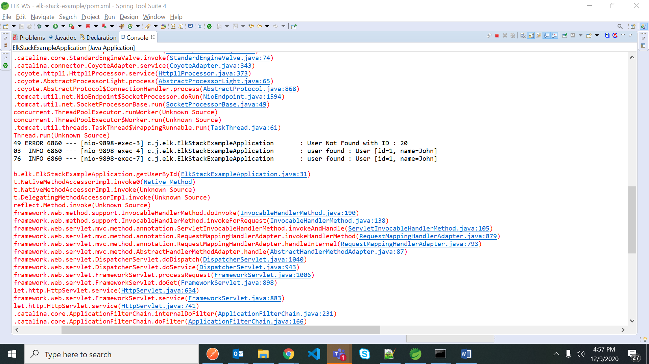

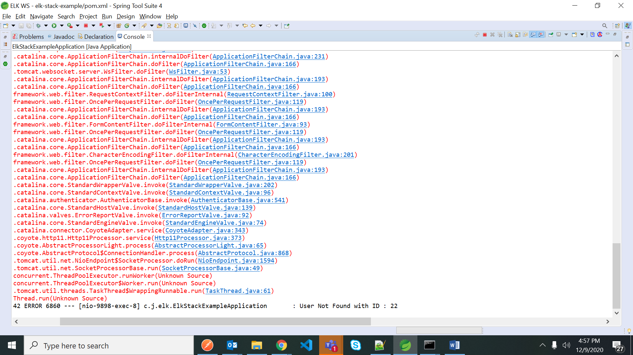

Goto log file and check

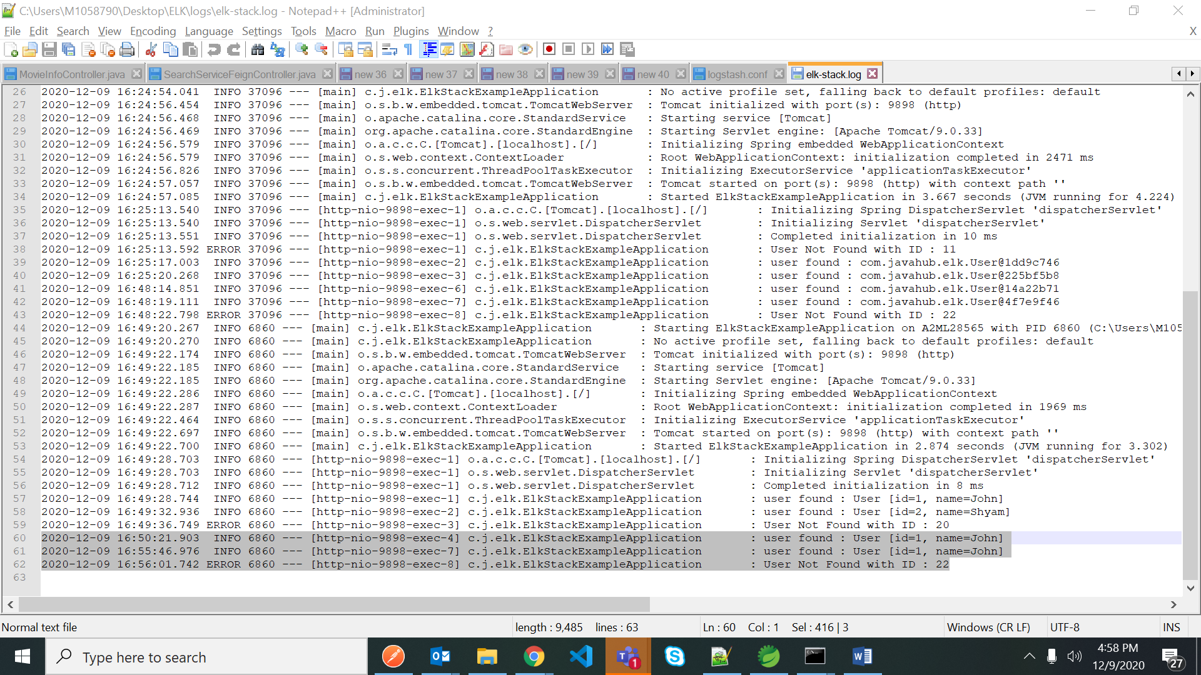

Goto logstash console to see the logs

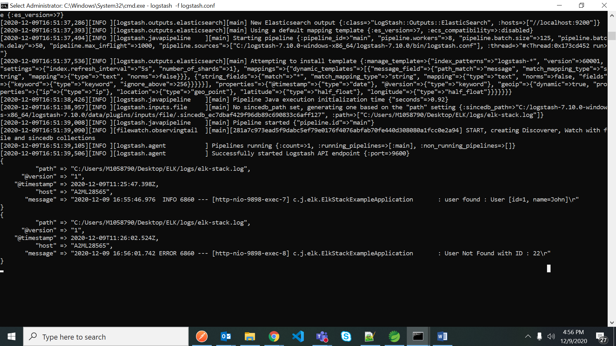

Open browser - http://localhost:9200/_cat/indices

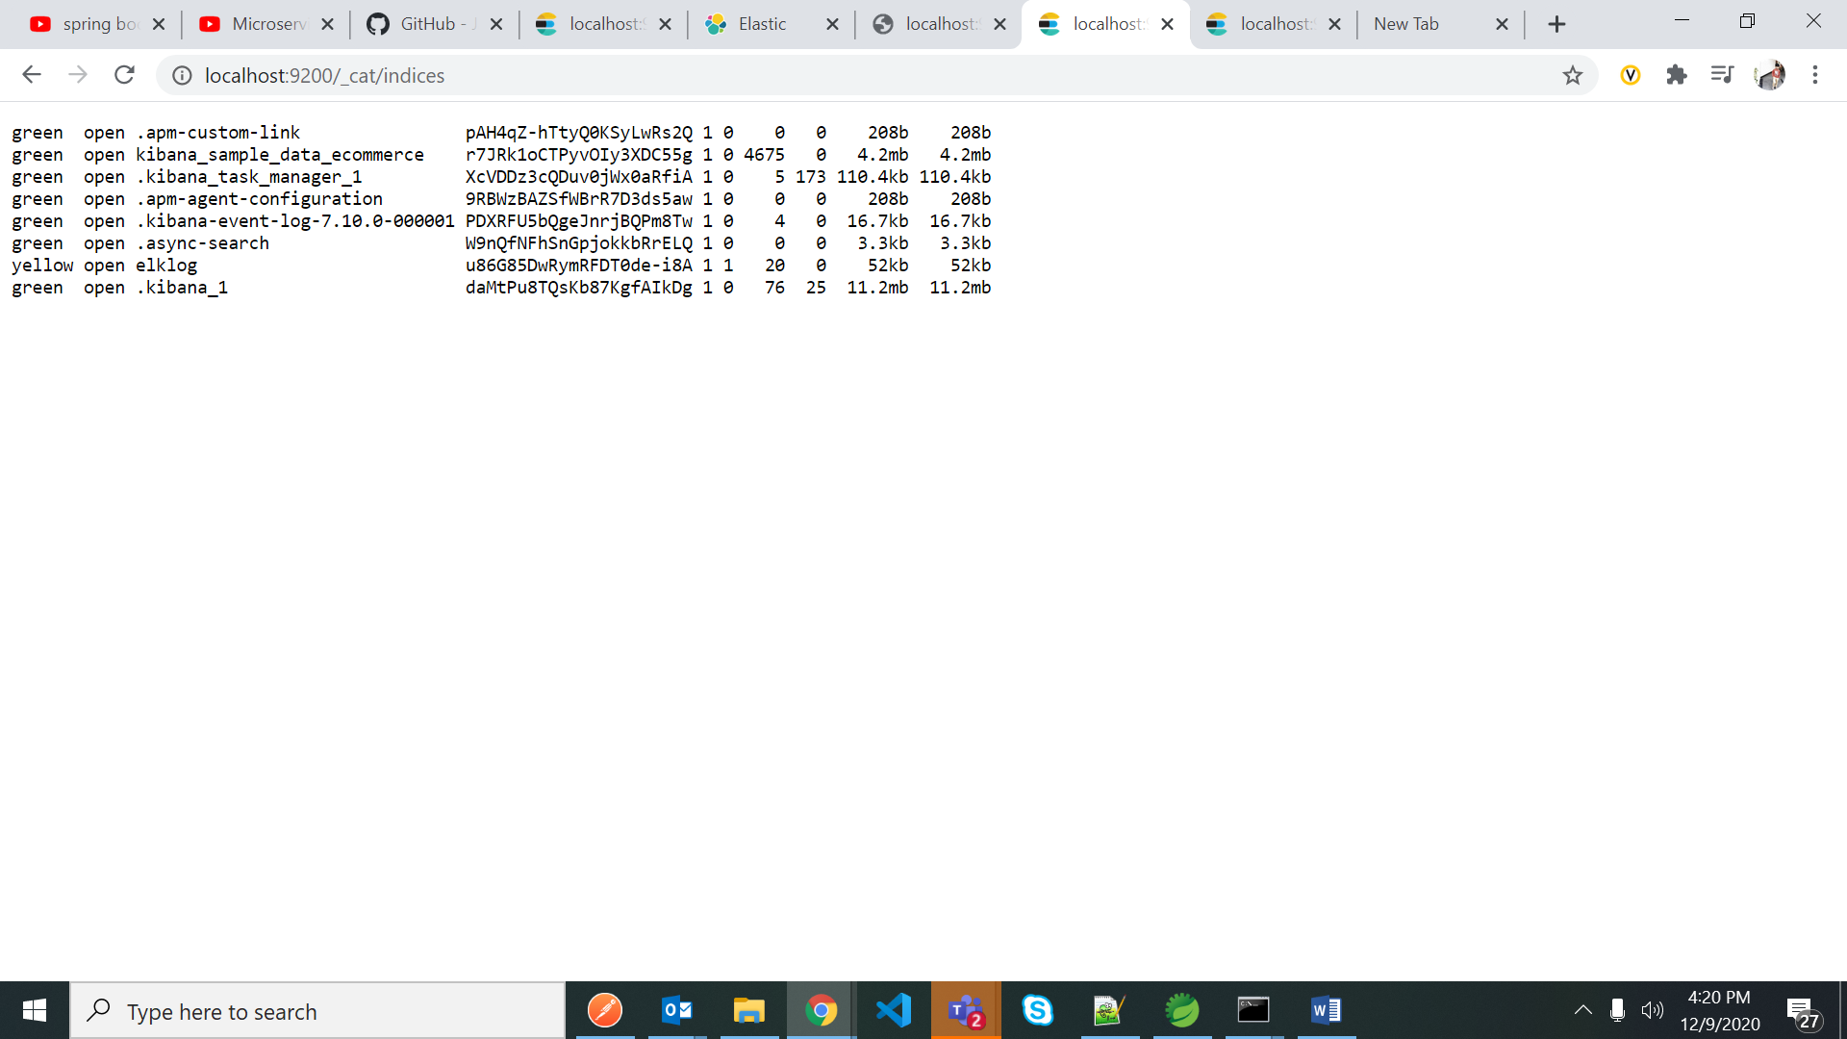

<http://localhost:9200/elklog/_search>

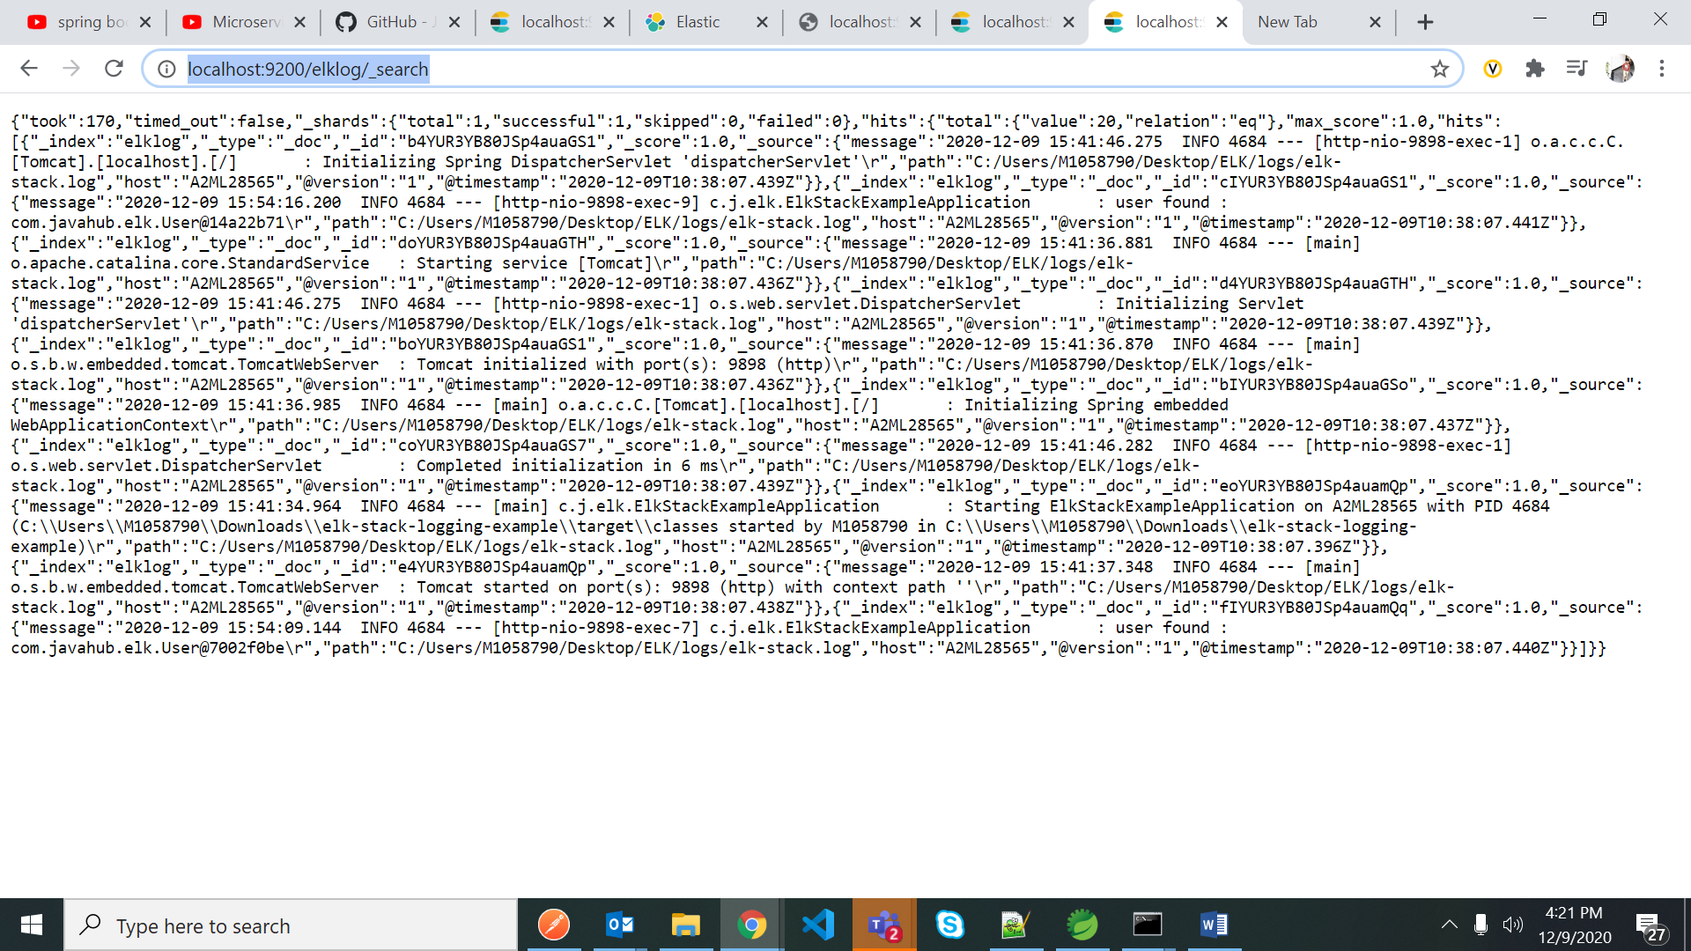

Open kibana stack management

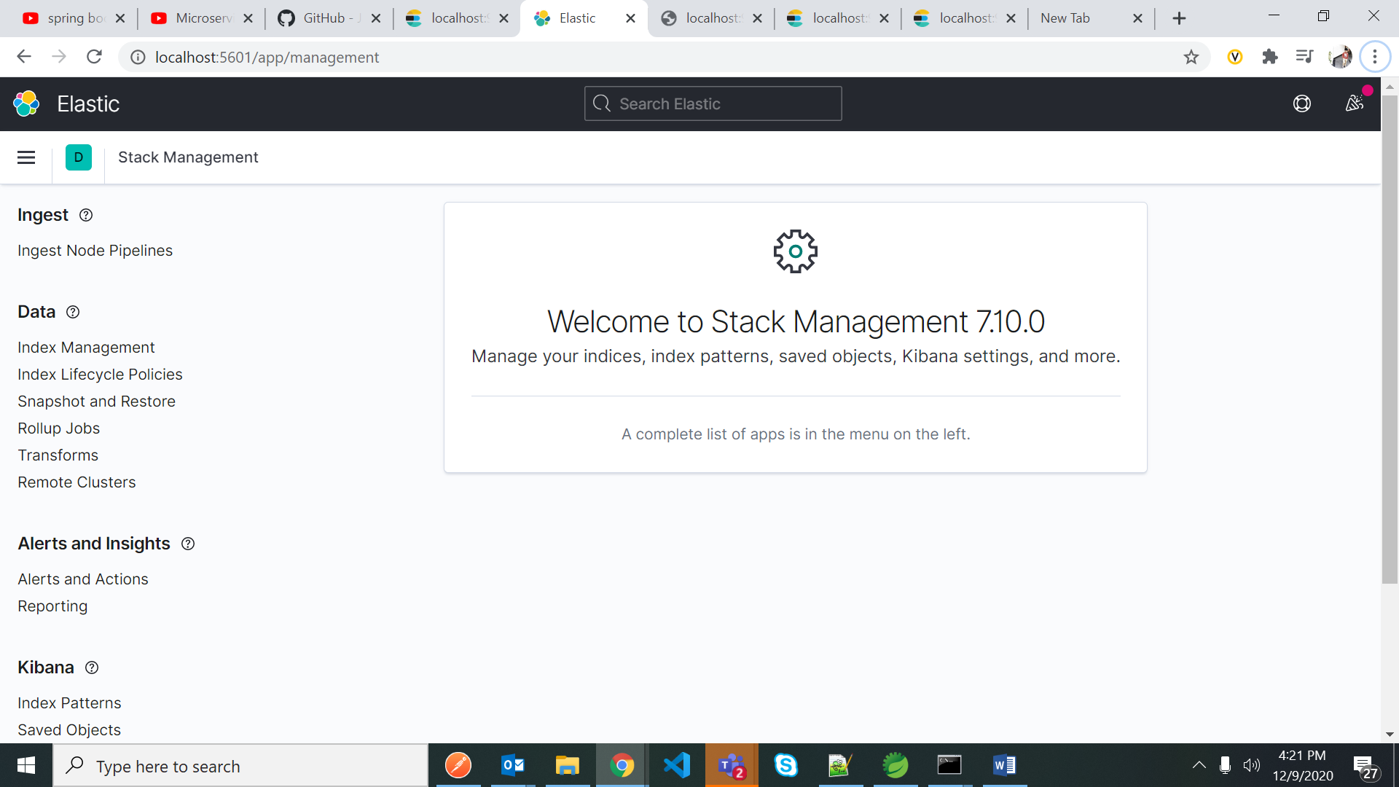

Goto index patterns

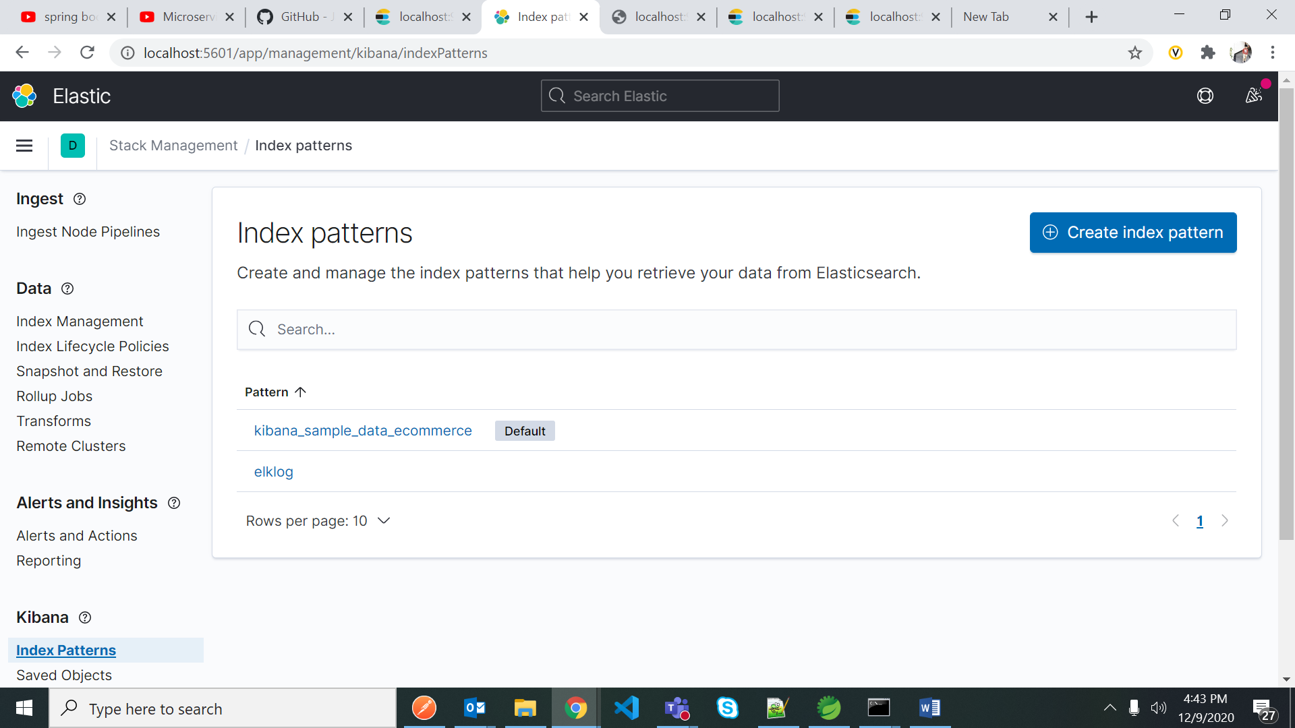

Create index – with proper index name and search for the index to view the logs

Index name – “elklog” as per logstash.conf file

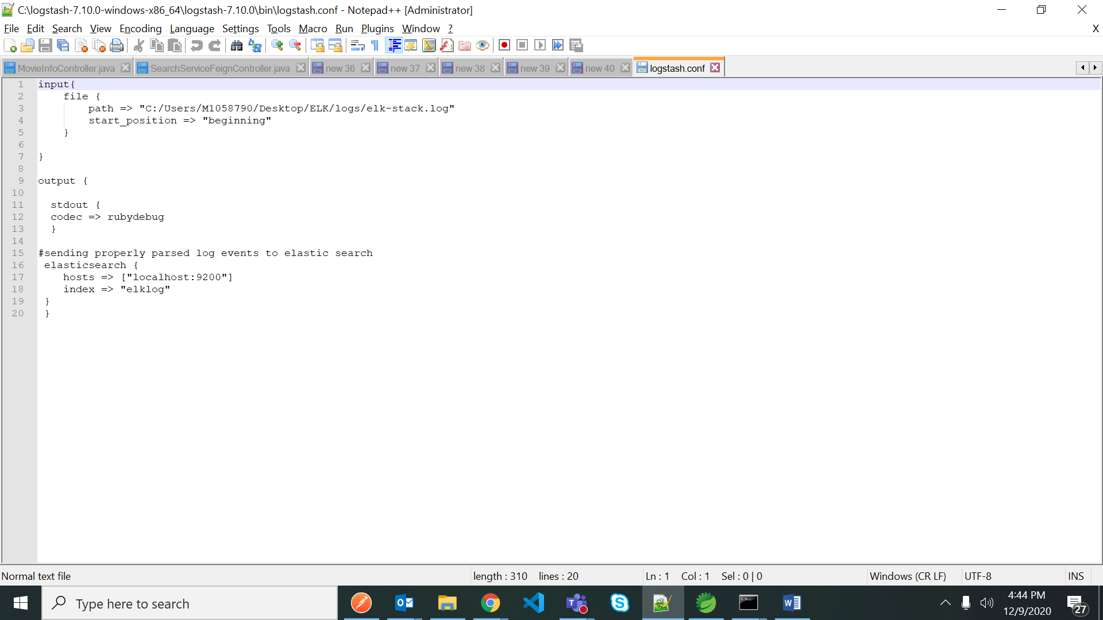

Then goto discover – tab

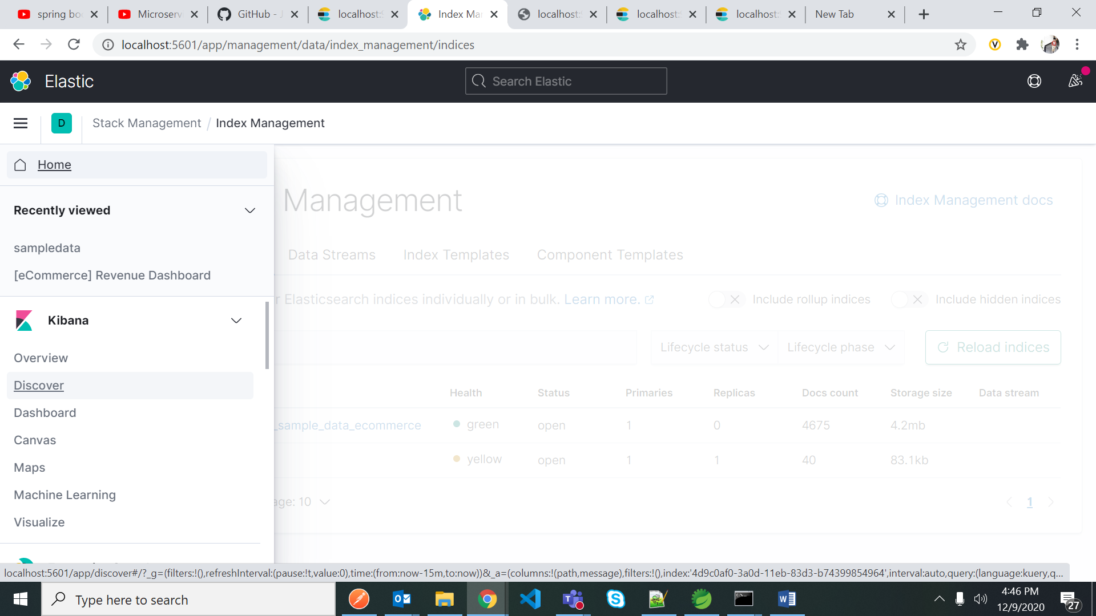

Select index pattern from here to see the application logs in Visualization tool Kibana

